1.Coursework four Results by Adrien Boukobza aeb115

2.The mean vector Hepatitis C data set is :

1.164 3.916 0.448 5.679 4.865 3.778 4.127 3.604 0.217

3.The covariance matrix of the Hepatitis C data set :

5.880 0.245 -0.004 -0.284 -0.346 -0.417 -0.481 -0.267 -0.067
0.245 7.572 0.073 -0.358 -0.346 0.257 2.273 0.946 -0.032
-0.004 0.073 0.247 -0.116 -0.039 -0.003 0.100 0.066 -0.005
-0.284 -0.358 -0.116 16.960 7.969 4.443 -1.036 -0.306 0.047
-0.346 -0.346 -0.039 7.969 8.361 4.921 -0.763 -0.752 -0.001
-0.417 0.257 -0.003 4.443 4.921 6.683 -0.087 -0.376 -0.141
-0.481 2.273 0.100 -1.036 -0.763 -0.087 20.583 1.122 0.014
-0.267 0.946 0.066 -0.306 -0.752 -0.376 1.122 4.317 0.119
-0.067 -0.032 -0.005 0.047 -0.001 -0.141 0.014 0.119 0.170

The eigenfaces of each component of the basis :

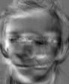
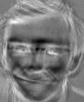
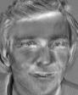
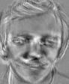
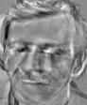

PrincipalComponent0.jpg PrincipalComponent1.jpg PrincipalComponent2.jpg PrincipalComponent3.jpg PrincipalComponent4.jpg

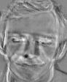
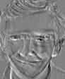
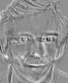
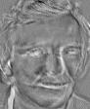
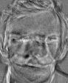

PrincipalComponent5.jpg PrincipalComponent6.jpg PrincipalComponent7.jpg PrincipalComponent8.jpg PrincipalComponent9.jpg

4.The component magnitudes for image “c.pgm” in the principal component basis used in task 4.4 :

1206.254 -1590.133 -248.136 -821.249 246.009 -771.900 963.633 376.967 161.599 -533.276

The images reconstructed are :
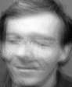
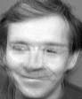
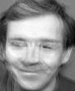
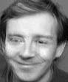
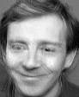

new_image_0.jpg new_image_1.jpg new_image_2.jpg new_image_3.jpg new_image_4.jpg

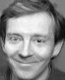
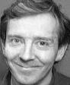




new_image_5.jpg new_image_6.jpg new_image_7.jpg new_image_8.jpg new_image_9.jpg

Question6 :

The eigenfaces of each component of the new basis :

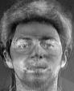
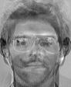
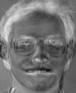

PrincipalComponent0.jpg PrincipalComponent1.jpg PrincipalComponent2.jpg

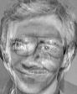
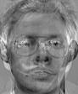
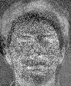

PrincipalComponent3.jpg PrincipalComponent4.jpg PrincipalComponent5.jpg

The images reconstructed are :

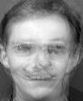
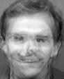
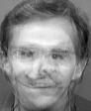

new_image_0.jpg new_image_1.jpg new_image_2.jpg

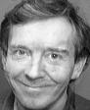



new_image_3.jpg new_image_4.jpg new_image_5.jpg

The component magnitudes for image “c.pgm” in the principal component basis used in task 4.6 :
-281.747 650.323 -150.020 1363.545 -1046.080 374.492

